**Name:** Caroline Dixon **Date:** 3/21/2022 **Max points:** 25

**Lab section: Monday**

**Show your work!!!**

**Acquire**

Week: 10

Date: 3/10/22 Year: **2022** Data: Christmas Dinner Costs Rising Again

**Source Article/Visualization:**

[**https://www.bbc.com/news/uk-england-38051644**](https://www.bbc.com/news/uk-england-38051644)

[**https://github.com/BBC-Data-Unit/christmas-dinner**](https://github.com/BBC-Data-Unit/christmas-dinner)

<https://www.makeovermonday.co.uk/data/data-sets-2016/>

**Represent**

**]**

**Critique**

Critique the visualization: what do you like about it, dislike about it, what do you plan to do differently? Remove this text and highlighting before submitting your work.

I like the clear chart layout where we can see the differences – the change in the axes is much appreciated to clearly show the fluctuating cost of dinner, and in addition it’s very clean and uncluttered. However, instead of having a legend for one single line I would simply label the y-axis as “Cost for 6 Servings in Euros,” which leads into a more drastic change in which I would need to have multiple lines on this graph for different food items to better show the overall increase in cost for the dinner. As it stands, the single red line is too vague and leaves far too much data out to drive home its message about increasing costs in Christmas dinner.

**Mine**

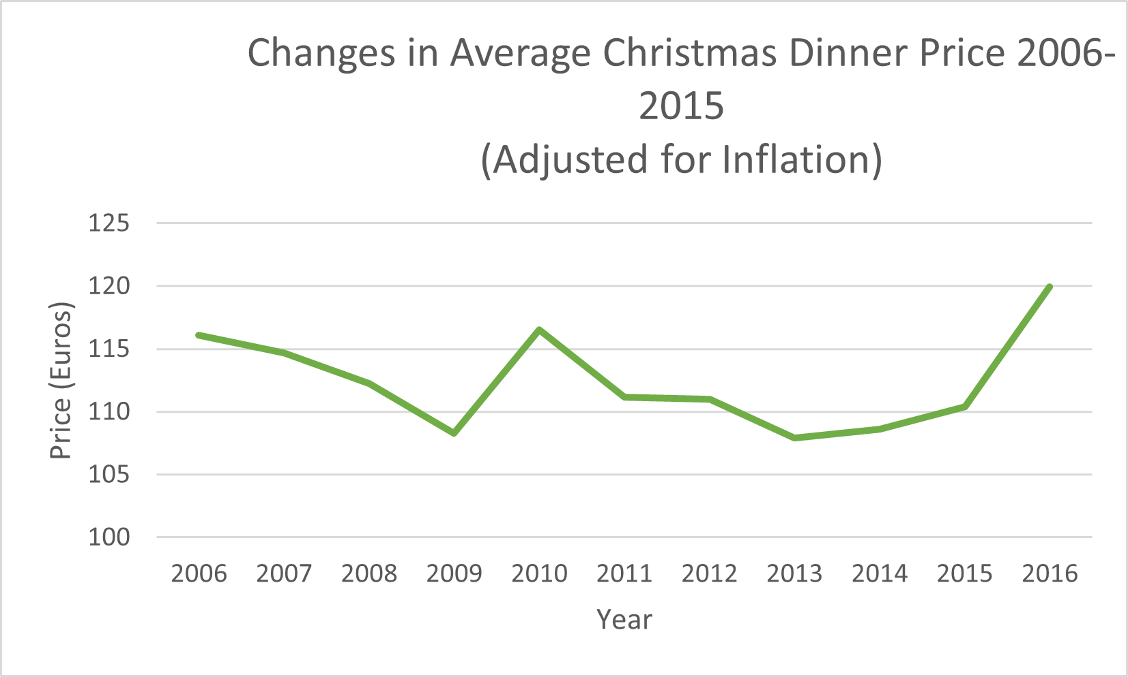Central Question: How much did the cost of Christmas dinner increase during 2016 as opposed to 2011-2015?

**Filter**

**-filtering not needed on the first two files**

**Stakeholders**

* My audience is people who celebrate Christmas and know the traditions
* My assumption is that people will know what will be in the categories if I merge them (know the traditions, etc)

**What to submit:** This document in PDF format only (if you do not know how to do this, see Lab 0 Exercise 1). Save this document as: LastnameFirstInitial_CGT270S22_MakeoverMonday#1.pdf

**Choose the best layout** for your makeover visualization: Portrait or Landscape, Remove the page of the layout that you DO NOT choose. No blank pages!

**NEW Sketch your Makeover**

In the space below, sketch out your ideas for refined visualization. You must use pen/pencil and paper to sketch out your idea, then take a photo of your sketch and include it in the space below.

**Refine (Makeover – Landscape view)**

Use an additional page if necessary. Remember, the purpose of visualization is “insight.” Take and include a screenshot of your visualization and include it below. Use Data Visualization Best Practices (see data visualization checklist). You MUST use more advanced chart types for your makeover. **Chart types that are not allowed: bar (single or stacked), pie, line charts, scatter plots, no tables.**



Figure Caption. Line chart showing changes in the average price of Christmas dinner between 2006 and 2016.

**Resources**

Data Visualization Checklist:

<http://stephanieevergreen.com/wp-content/uploads/2016/10/DataVizChecklist_May2016.pdf>

How to give constructive criticism:

<https://personalexcellence.co/blog/constructive-criticism/>

Sample Makeovers

<https://www.makeovermonday.co.uk/gallery/>

**Grading Rubric**

|  |  |  |  |
| --- | --- | --- | --- |
| **Excellent** | **Good** | **Fair** | **Needs Improvement** |
| Meets **ALL** or most of these: Makeover is esthetically pleasing (color, perception), best practices followed (insightful), Correct dataset downloaded; provided an interesting point of view of the data; critiqued previous makeover, critique is constructive (indicates one thing that is done well, and one thing that could be done differently, what will be done to improve the visualization), assumptions (more than one) are listed.  [15 pts] | Meets **MOST** of these: Makeover is esthetically pleasing (color, perception), best practices followed (insightful), Correct dataset downloaded; provided an interesting point of view of the data; critiqued previous makeover, critique is constructive (indicates one thing that is done well, and one thing that could be done differently, what will be done to improve the visualization), assumptions (more than one) are listed.  [10 – 14 pts] | Consistently meets **SOME** of these: Makeover is esthetically pleasing (color, perception), best practices followed (insightful), Correct dataset downloaded; provided an interesting point of view of the data; critiqued previous makeover, critique is constructive (indicates one thing that is done well, and one thing that could be done differently, what will be done to improve the visualization), assumptions (more than one) are listed.  [5 – 9 pts] | Little to no evidence of the understanding of the data visualization process.  Lackluster makeover or no makeover.  Little effort.  [0 – 4 pts] |
| Sketch included: hand drawn, data vis best practices evident.  [5 pts] | Sketch included: hand drawn, lacking data vis best practices.  [3 pts] | Sketch included, but was generated by computer  [2 pts] | No sketch included.  [0 pts] |
| More advanced chart types used  [5 pts] | More advanced chart types used, followed most best practices  [3 pts] | Basic chat types used in the makeover  [2 pts] | Little to no improvement in visual representation of the data [0 pts] |